User Guide 33A Installing and backing up your digital certificate
Purpose of this Guide
The purpose of this guide is to provide information on how to install and back up your digital certificate.
Notes
- This guide follows on from User Guide 32 - Applying for a Certificate Manager digital certificate, or from User Guide 35 – Applying for a standard digital certificate.
- Once your certificate has been approved by DigiCert, you will receive an email containing instructions to assist you with installing it.
- If you are required to install your certificate on a USB Security Token, follow the steps in ‘User Guide 33B – Installing a digital certificate on a USB Security Token’ instead.

33.1 Install your digital certificate
To commence the installation of your certificate, click on the hyperlink contained in the email sent to you from DigiCert.
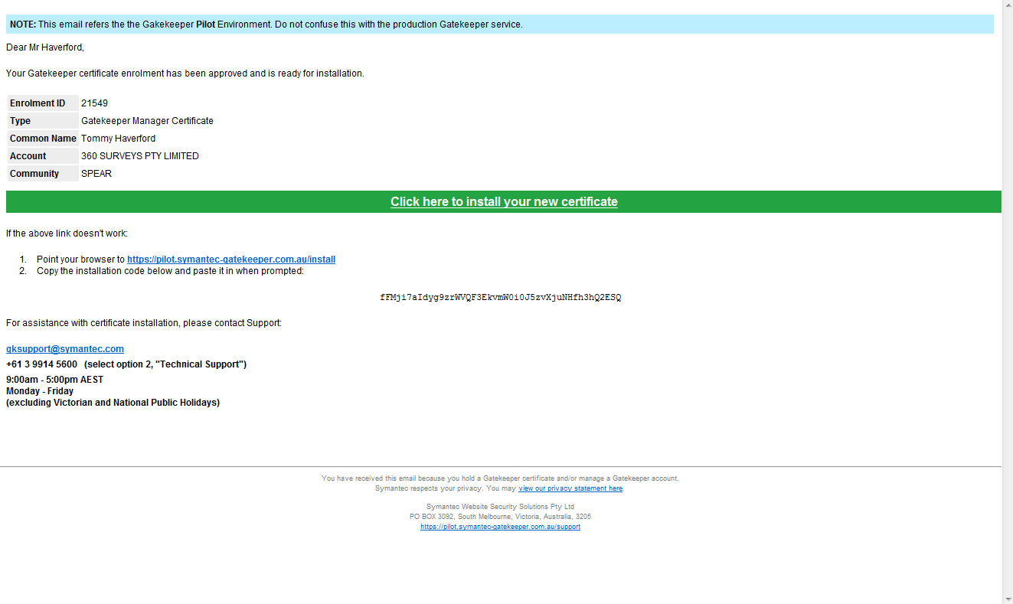

Complete the following steps:
1. Confirm the details displayed are correct.
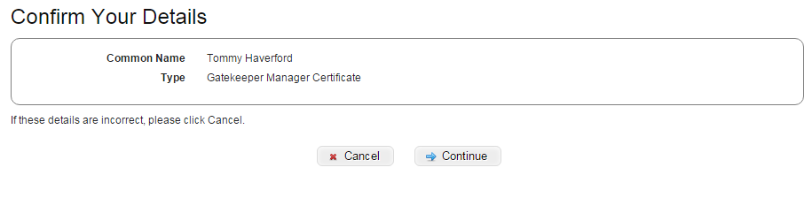

Click on ‘Continue’.

2. Have your mobile phone ready.
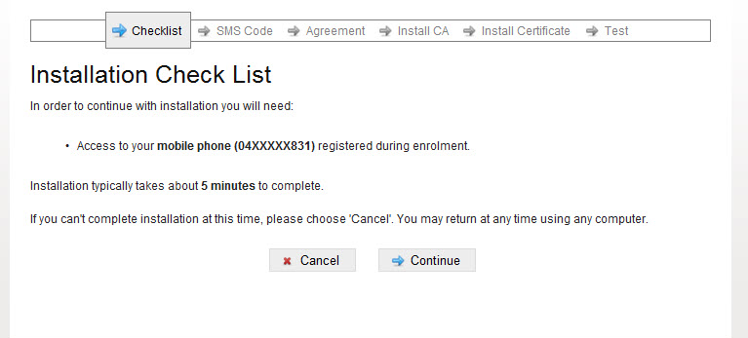

Click on ‘Continue’.

3. Enter the code sent to your mobile.
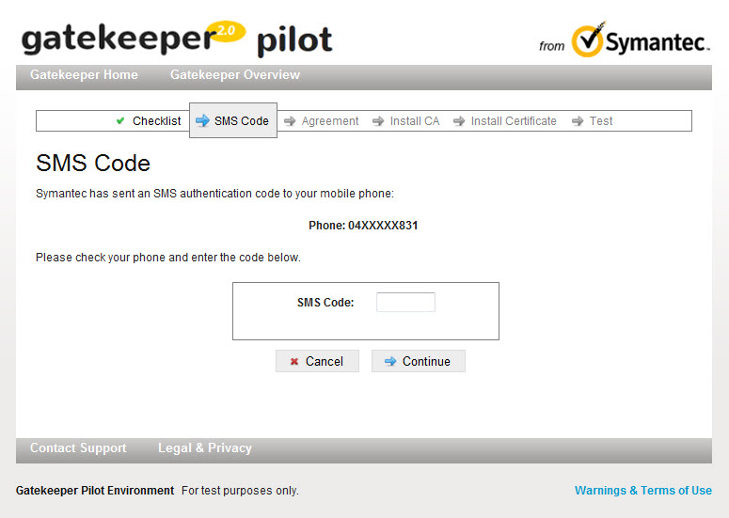
Enter code and click on ‘Continue’.

4. Read and agree to the subscriber agreement. A copy can be downloaded for your records.
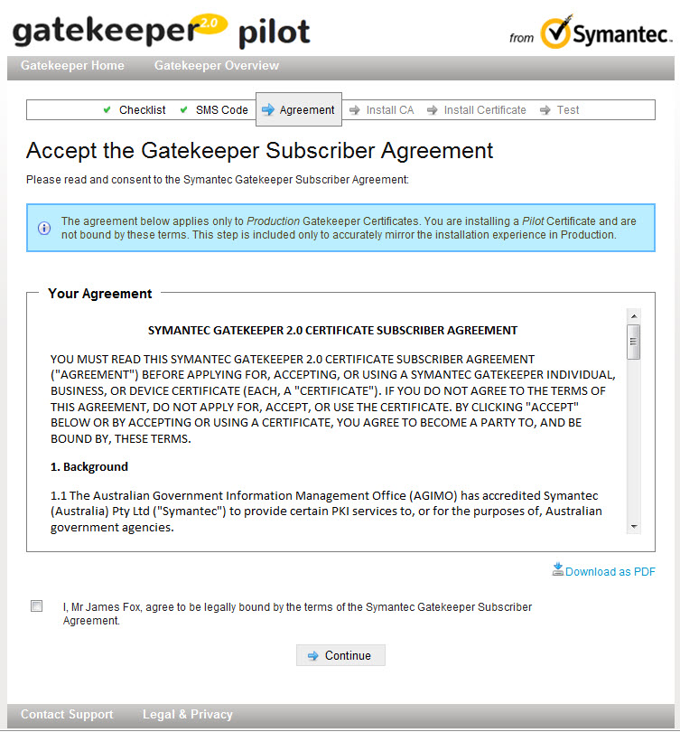
Agree and click ‘Continue’.

5. Your digital certificate file will be downloaded automatically. Copy or take note of the temporary password displayed on screen and then open the downloaded certificate file.
You will need this password to install your digital certificate.

Note: If you are unable to find the file, check your downloads folder.
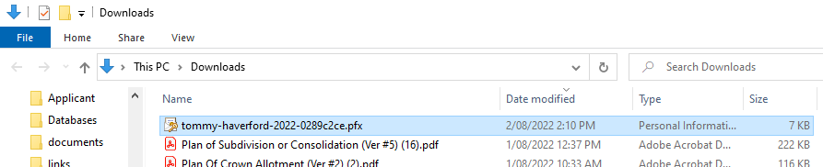

Double-click to open the certificate file.

6. The certificate import wizard opens. Depending on your Operation System version, the Certificate Import Wizard may look different or present other options. You can generally accept the default values.
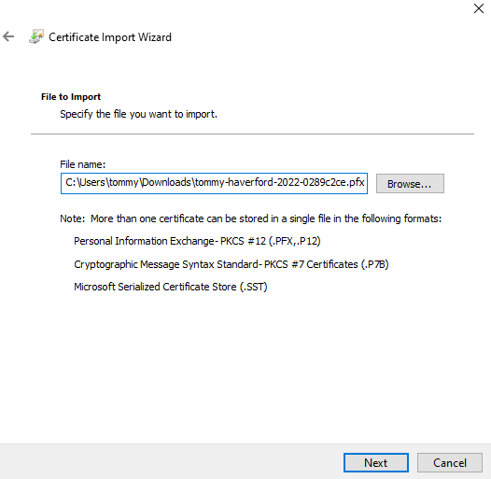
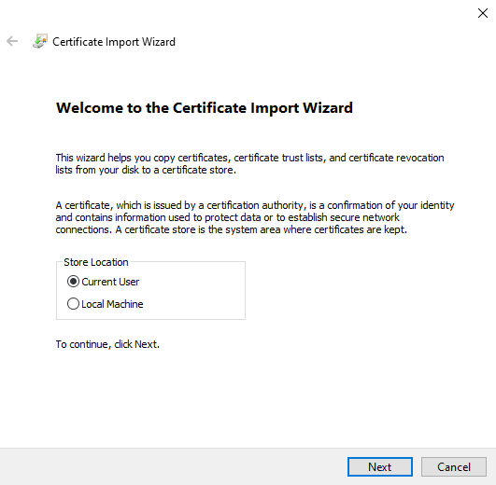

7. Enter the password copied or noted in step 5. Ensure you tick all available Import options.
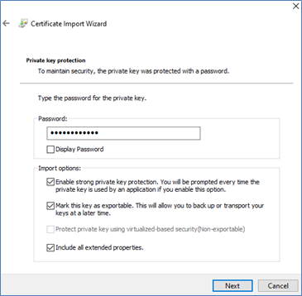

Enter or paste the copied password.

Tick all available import options.

8. Accept the default values on the following screens.
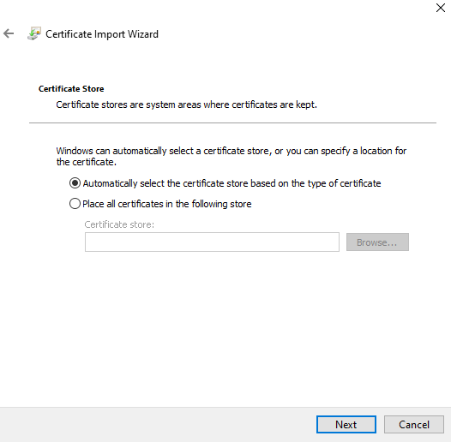
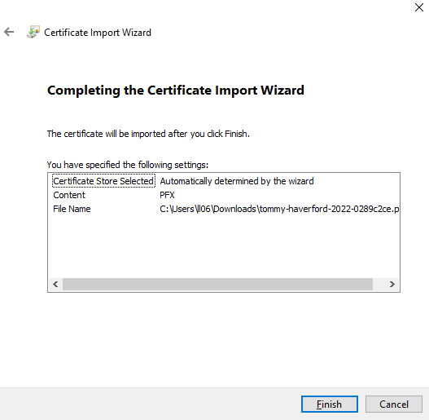

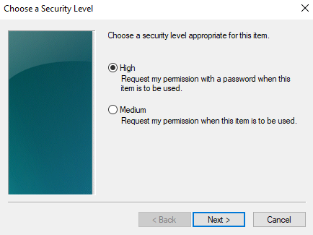
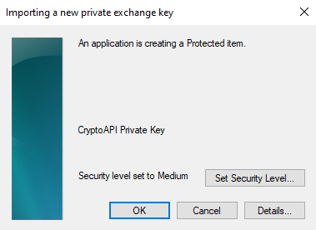
9. Set security level to ‘high’.

10. Set a password to protect your digital certificate and to digitally sign in SPEAR.
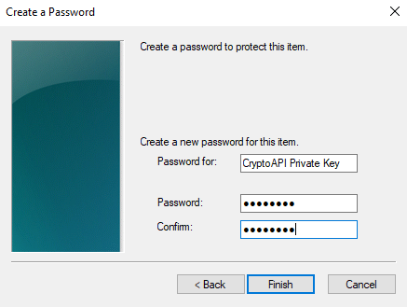

Enter and confirm a new password to protect your digital certificate.
This is the password that you will be asked to enter when you digitally sign in SPEAR.

11. The security level should now be set to ‘high’. Click ‘OK’ to complete the certificate installation.
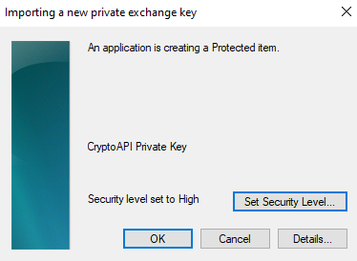

A window will pop up to confirm the certificate was imported successfully. Click ‘OK’ to close any open windows and return to the DigiCert installation process before continuing to the next step.
12. Test certificate.
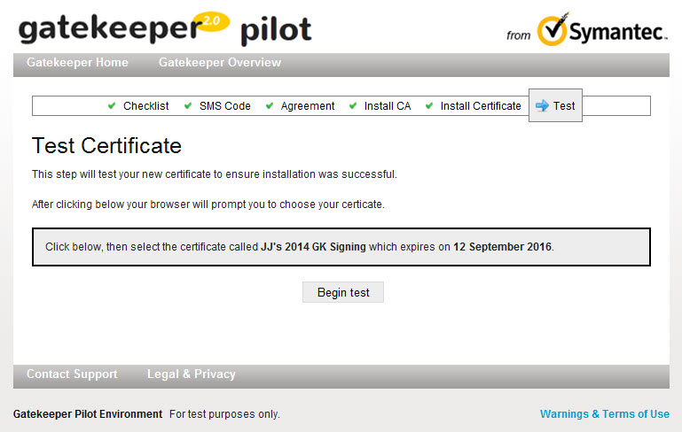
Read the instructions then click ‘Begin Test’.

13. Select certificate to test.
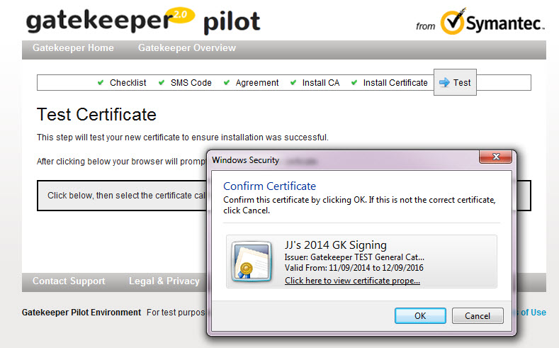
Choose the correct certificate then click ‘OK’.

14. Enter your signing password.
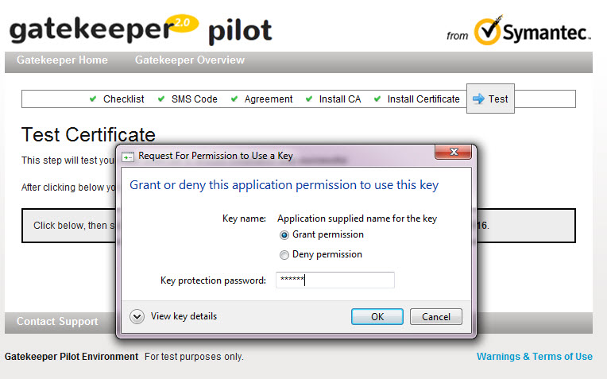
Select ‘Grant Permission’, then enter your ‘signing’ password and click ‘OK’.

15. Test completed successfully. Please continue with the following section to back up your certificate.
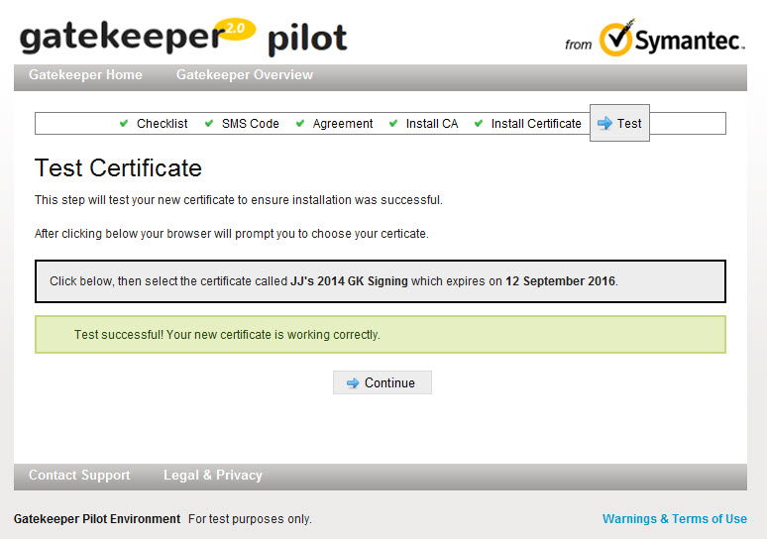
Test was successful, click ‘Continue’.

33.2 Back up your digital certificate
16. Click on the Windows start button and type “Internet Options”. When the Internet Options icon appears, click on it to open the Internet Properties window.
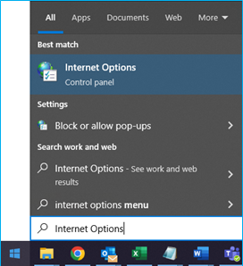

17. Click on the ‘Content’ tab and then click on the ‘Certificates’ button.
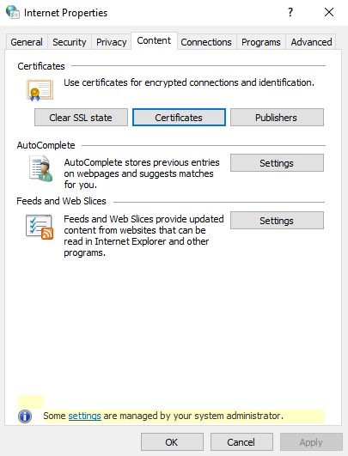

18. From the ‘Personal’ tab, click on the certificate you use in SPEAR and then click on the ‘Export’ button.
Note: Ensure the certificate is valid and issued by “DigiCert Gatekeeper Issuing CA”.
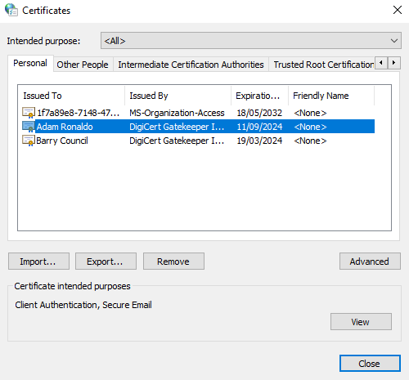

Certificates used in SPEAR are issued by DigiCert Gatekeeper Issuing CA

19. Click ‘Next’ on the first screen of the Certificate Import Wizard. On the second screen, select ‘Yes, export the private key’ and click ‘Next’.
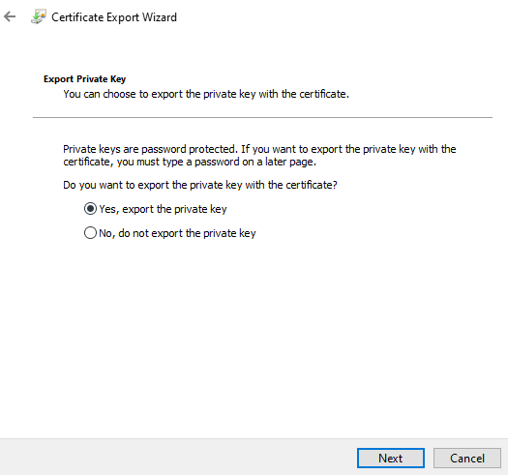

Select ‘Yes’ to export the private key.
NOTE: Failing to do this step will result in your backup files being in the incorrect format.

20. Ensure ‘Personal Information Exchange’ is the selected format and select the relevant options below before clicking ‘Next’.
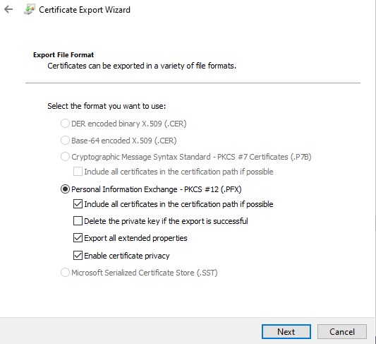

Ensure that you DO NOT TICK ‘Delete the private key if the export is successful’. All remaining options can be ticked.

21. Ensure the password checkbox is ticked and enter a password to protect your digital certificate back up file. You may wish to use the same password that you set in step 10 of this guide. Depending on your operating system, you may need to use at least eight characters, one of which should be uppercase.
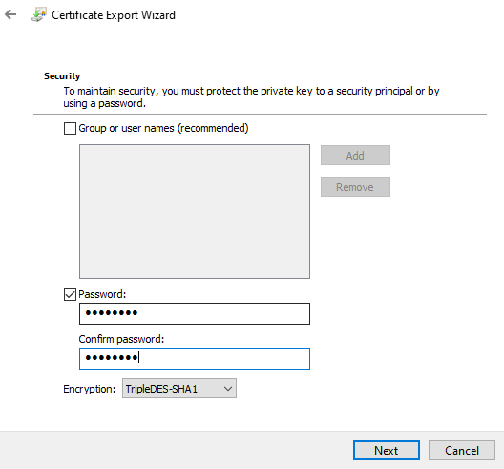

22. Click ‘Browse’ and select a folder in which to store your digital certificate back up file. Enter a recognisable file name and click ‘Save’. Click on the ‘Next’ button and then click on the ‘Finish’ button.
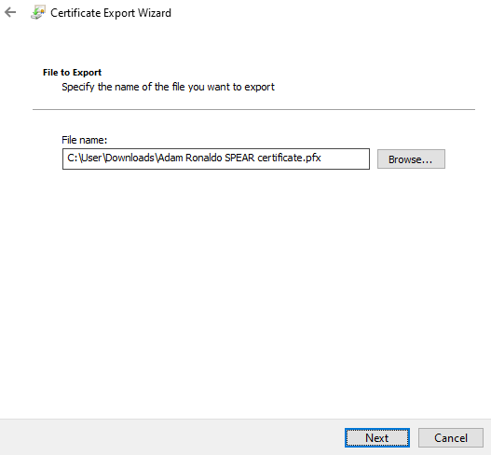

23. If you are prompted to provide the password for your digital certificate, enter it in the Password field and click ‘Allow’, otherwise just click ‘Allow.
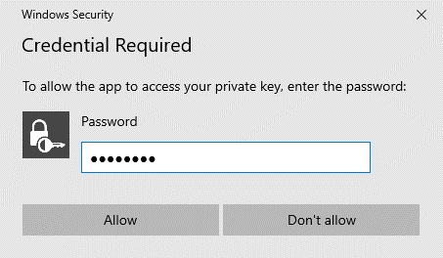

If you are not prompted for a password, simply click on ‘Allow’.

If the password was correct, you will receive confirmation that the export was successful. You should now have a digital certificate back up file with a .pfx file extension located in the nominated folder.
33.3 What next?
Certificate Manager digital certificate holders can now approve standard digital certificates for other members of your organisation. Please refer to User Guide 37 - Certificate Manager guide to managing certificates.
If you will be using your digital certificate in SPEAR to sign key documents, you can now test it. Please see User Guide 34 – Testing your digital certificate for more information.

Need more information?
Further information on this topic can be found by:
- Visiting the SPEAR website www.spear.land.vic.gov.au/SPEAR.
- Contacting the SPEAR Service Desk on 9194 0612 or email spear.info@delwp.vic.gov.au

